Exploring GCC optimization

For -O0

riscv32-unknown-elf-gcc -march=rv32imac_zicsr_zifencei -mabi=ilp32 -S -O0 hello.c -o hello_O0.s

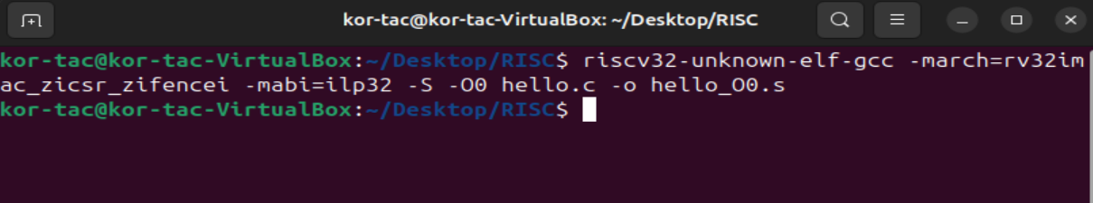

For -O2

riscv32-unknown-elf-gcc -march=rv32imac_zicsr_zifencei -mabi=ilp32 -S -O2 hello.c -o hello_O2.s



For hello_O0.S

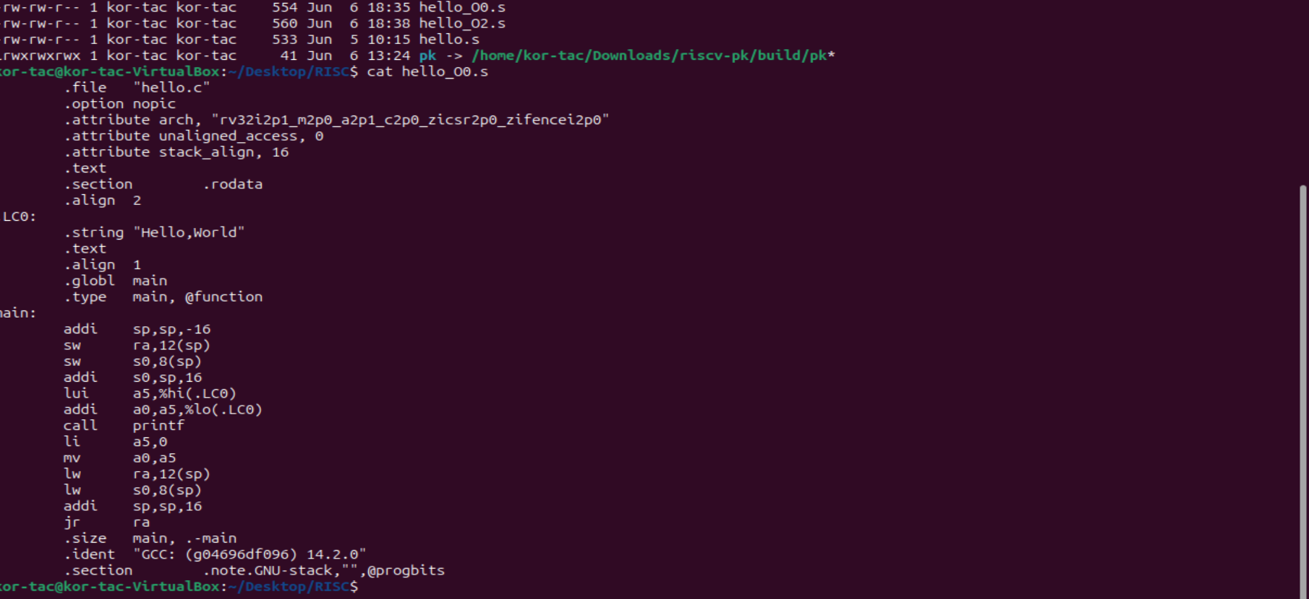

For hello_O2.S

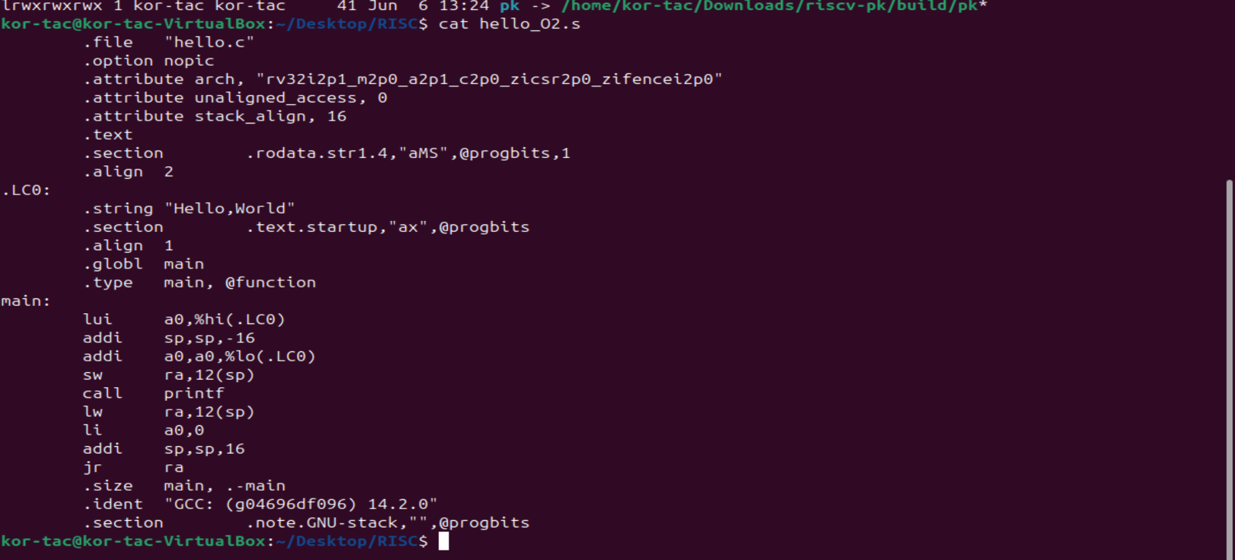

| **Aspect** | **-O0** | **-O2** |
| --- | --- | --- |
| **Assembly Length** | Much longer | Much shorter |
| **Redundant Instructions** | Present | Removed |
| **Register Usage** | Inefficient | Optimized |
| **Function Calls (like printf)** | Fully preserved | Might be inlined or minimized |
| **Loop Handling** | Straightforward | Might be unrolled or optimized |
| **Memory Accesses** | Frequent and direct | Cached in registers or optimized away |